

RESUME &
COVER LETTER
GUIDE

RESUME:
YOUR PERSONAL MARKETING TOOL
A resume is a brief, well-organized summary of your background and experiences. Its purpose is to interest a potential employer in your qualifications and to land an interview!

IMPORTANT POINTS TO REMEMBER:

- Make sure your resume is visually appealing and use consistent formatting.
- Be BRIEF. Use sufficient and powerful phrases.
- Be SPECIFIC. Use numbers or percentages to quantify and show results.
- Use Action Verbs. See sample list on page 4.
- Use “Key Words” and phrases contained in the job description.
- Use bullet point statements.
- Check spelling and grammar. Avoid abbreviations.
- Include your QPA if 3.0 or above.
- Keep your resume to one page. Typically, only working professionals with 10+ years of experience should have a 2 page resume.
- Use a 10, 11, or 12-point type. Never smaller than 10.
- If you need to, you may use .5 margins, but not smaller.
- Eliminate first person pronouns (I, me).
- When hard copies are needed (interview, job fairs, etc.), print your resume on laser printed bond paper.
- Keep the format simple – no fancy graphics or pictures.
- Realize there is not just one “right” way to organize your resume. Get several opinions, but remember that everyone may tell you something different.
- Create a Reference List (see sample on page 16) on a separate page.
- Always remember to submit your resume for an online application as a PDF file, not a Word Doc!
- Don’t list your high school information unless you are a freshman or sophomore applying for an internship OR if your high school is related to the position for which you are applying (ex. Teacher candidate applying to his/her own high school).

HOW TO GET STARTED

- Read through this guide. Look at samples and choose a format that fits your background and preferences (More resume samples are located in Career Services Office).

- Start brainstorming by jotting down your educational background, related experiences, internships, study abroad, summer jobs, volunteer experiences, and campus activities.

- Write down any honors, awards or scholarships you’ve received.

- Jot down any special skills: foreign languages, computers, lab equipment, training or certifications.

- Schedule an appointment with Career Services to critique your resume and/or cover letter or email your resume to Career Services.

TIPS FOR WRITING A COLLEGE RESUME

Keep these tips in mind before crafting your resume!

- Focus on education. Emphasize your academic history. Along with the name of your school and degree, include any achievements, such as a high GPA or any academic awards. If you have taken courses related to the job you’re applying for, list those as well.

- Include relevant jobs. Think about the skills and experiences required of the job you want. Include any jobs where you developed these qualities. Even if your work experiences aren’t directly related, think of ways to highlight experiences you had that are relevant to the job you want. For example, you might include a former job as a cashier if it helped you develop customer service or leadership skills.

- Include extracurricular activities. Because you likely have limited work experience, emphasize any non-work activities. These might include clubs, sports, babysitting, volunteer work, or community service. All of these activities can show your skills and abilities.
- Include leadership experience. Have you held a position in a club, or been a captain on a sports team? Have you had any leadership responsibilities at your previous jobs? Be sure to list these experiences, as they show your ability to lead a team.

- Use action verbs. Action verbs help show your responsibility. When describing your achievements, use action words. Words like led, researched, and created to portray your experiences in an energetic way. See next page for action verb examples.
- Quantify when possible. Whenever possible, include numbers to show your achievements. For example, you might say that you worked the cash register at a store that managed $10,000 daily, or that you helped 50-100 customers daily at your retail job.

- Edit, edit, edit. Proofread your resume carefully before submitting it. A clean, error-free resume will make you look professional. Ask a friend or family member to read the resume for you as well.

- Use a resume sample. Use multiple samples to guide your own writing. A resume sample can help you decide what kind of content to include, as well as how to format your resume. However, be sure to tailor a resume example to fit your own experiences, and the job you are applying for. Overview the samples in this guide and/or visit our office to pick up more samples!

Source: The Balance, 2016
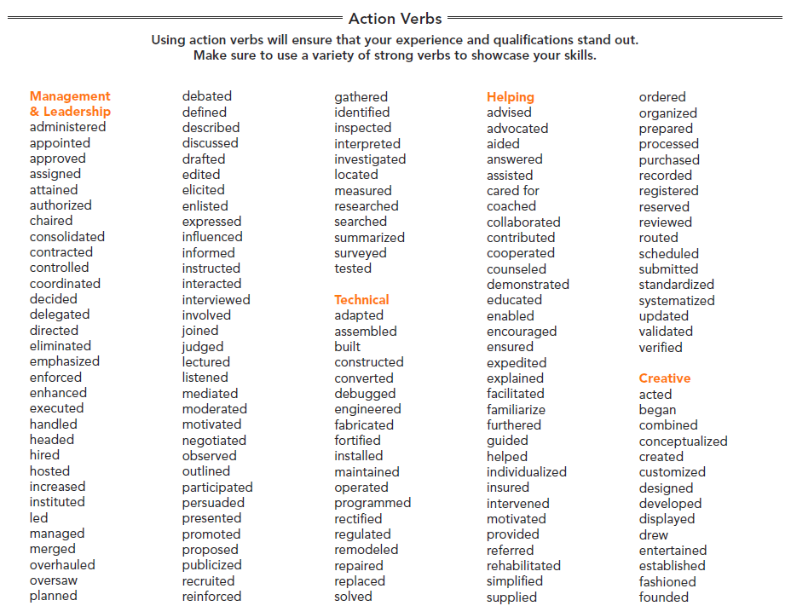

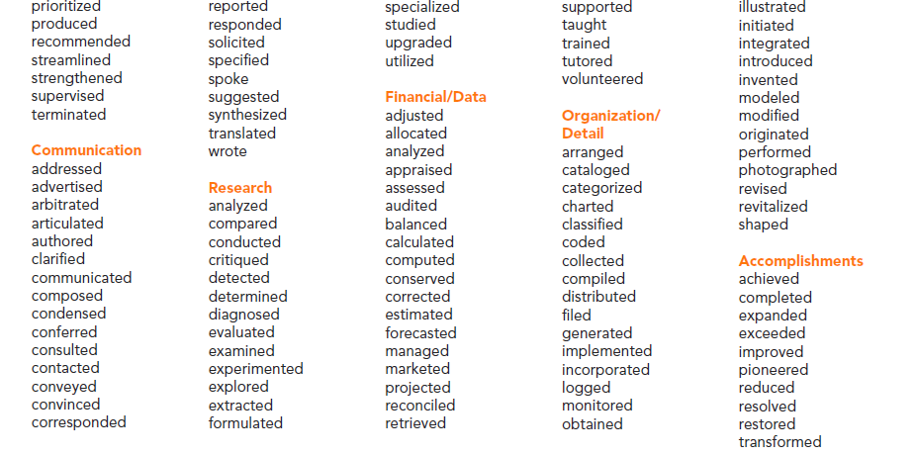

JOHN A. MANZO

| 123 West Main Street, Loretto, PA 15940 | 814-472-1234 | jamst5@gmail.com |

www.linkedin.com/in/johnmanzo

EDUCATION Saint Francis University – Loretto, PA
Bachelor of Science in Social Work
Minor: Management
Expected Graduation: May 20xx
Dean’s List, Overall QPA: 3.5/4.0, Major QPA: 3.7/4.0

RELATED Social Work Intern, Appalachian Youth Services – Ebensburg, PA
EXPERIENCE Spring 20xx
      - Assisted in group counseling for 10 juveniles
      - Planned group field trips – one per month
      - Gained general knowledge in counseling (intake and assessments, report writing, reality therapy)

ADDITIONAL Tutor, Learning Resource Center, Saint Francis University – Loretto, PA
EXPERIENCE Fall 20xx
- Tutored two freshmen and three sophomores in introductory courses in finance and management

Bank Teller, Mellon Bank – Altoona, PA
Summers 20xx and 20xx
- Handled customer transactions and strengthened interpersonal skills through interaction with the public

Camp Counselor, Camp Hide-A-Way – Mount Pocono, PA
Summer 20xx
- Planned daily and individual activities
- Worked directly with 20 children
- Supervised four camp counselors

ACTIVITIES/ National Association of Social Workers, 20xx – Present
LEADERSHIP Volunteer, Johnstown Women’s Shelter, 20xx – Present
Social Work Club, Vice-President, 20xx – 20xx
Saint Francis University Swim Team, NCAA Division I, 20xx – 20xx Alpha Delta Mu Honor Society, Inducted Spring 20xx

TRAINING/ CPR/First Aid Certified
SKILLS Fluent in Spanish

RELEVANT | Introduction to Social Welfare | Human Behavior in the Social Environment |
COURSEWORK | Social Welfare Policies, Programs, and Issues | Developmental Psychology |
| General Sociology |The Family in Theory and Practice | Social Research |
| Cultural Diversity |
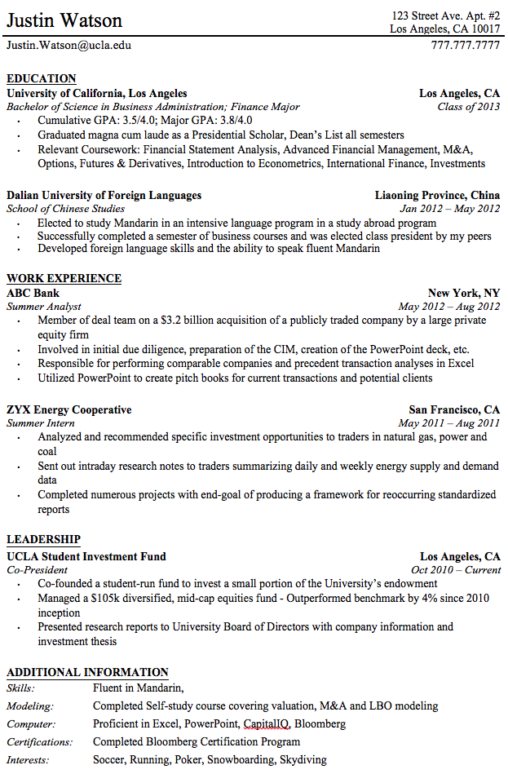

JANE A. HARRIS
123 Baum Boulevard, Pittsburgh, PA jahst3@francis.edu (421) 111-1234
www.linkedin.com/in/janeharris

EDUCATION
Saint Francis University, Loretto, PA Expected Graduation: May 20xx
Bachelor of Science in Computer Science
Minor: Management Information Systems
QPA: 3.3/4.0

HONORS
- Dean’s List, Fall 20xx
- All-American Scholar Athlete
- Named to Who’s Who Among American Colleges and Universities

COURSEWORK
Programming, Database Management, Statistics, Psychology, Management Information Systems,
E-Commerce, Public Speaking, Introduction to Computer Science

TECHNICAL SKILLS

JAVA (Netbeans/Notepad++), HTML (JSP, CSS, XML), Vi/Vim (Linux)

EMPLOYMENT EXPERIENCE

Cashier: Big Lots, Pittsburgh, PA Summer 20xx

Assisted customers with questions and concerns

Constructed store displays and organized merchandise

Trained new cashiers

Sales Associate: Shoe Store, Pittsburgh, PA Summers 20xx & 20xx
- Controlled daily cash flow
- Assisted and accommodated customer needs
- Prepared bank deposits and responsible for closing

ACTIVITIES/ LEADERSHIP
- Computer Club, Vice President 20xx – Present
- NCAA Division I Women’s Golf Team 20xx – Present
- Tour Guide, SFU Admissions Office 20xx – Present
- Student Government Organization 20xx – 20xx
- Best Buddies 20xx – 20xx

Samuel Burton
3226 McDonald Way, San Diego, CA 92129 • sxb109@francis.edu • 805-544-1234
www.linkedin.com/in/samburton

EDUCATION Saint Francis University, Loretto, PA Expected Graduation: May 20xx
Bachelor of Science in Environmental Engineering Overall GPA: 3.7/4.0
Concentration: Ecological Engineering
Minor: Psychology

ENGINEERING
EXPERIENCE Intern, San Diego County Public Works Department, San Diego, CA May – Aug 20xx
• Assumed responsibility for Annual Weather Observation Program
• Provided support in acquisition and analysis of all county stream gauge data
• Aided in the development of the County Groundwater Monitoring Program
• Redesigned and optimized county Groundwater Measurements Database for ease of use and efficiency
RESEARCH Acid Mine Drainage, Bolivia Summer 20xx
- Performed water sampling in active/passive treatment systems and negative pH water
- Used sampling techniques such as alkalinity, turbidity, pH, dissolved oxygen, and total dissolved solids

SKILLS Engineering: AutoCAD, Mathlab, Python, HEC-RAS, Water Sampling
Language: Fluent in English and Spanish
Knowledge of various basic laboratory procedures
Field-scale design
Theory and computer modeling
EMPLOYMENT
EXPERIENCE Assistant Manager, Sheetz, Altoona, PA Jan 20xx – Present
- Manage a team of 10 employees and train all incoming employees
- Oversee store operations and balance numerous office tasks
- Gain communication skills by interacting with 20–25 customers on a daily basis

Tutor, Saint Francis University, Loretto, PA Aug 20xx – Present
- Tutor students in the fields of Calculus, Chemistry, Physics, and Statistics

Unit Leader/Counselor, Camp Vista, San Diego, CA Summers 20xx – 20xx
- Supervised 20 male campers ages 10–15 years old
- Taught survival skills and planned unique and fun programs

ACTIVITIES/
LEADERSHIP Environmental Engineering Society Fall 20xx – Present
NCAA Division I Soccer Team, Saint Francis University Fall 20xx – Present
- Team Captain
- NEC Conference Champion
Sigma Chi International Fraternity, Lambda Rho Founding Father Spring 20xx – Present
- Pro Consul
- Philanthropy Chair
Knights of Columbus, Council #8222 Fall 20xx – 20xx
Freshmen Orientation Counselor Fall 20xx – 20xx
- Associate Director
PAGE JASANOFF
1110 ½ Hay Street, Fayetteville, NC 28305 ∙ pjasanoff@gmail.com ∙ (910) 483-6611

CAREER GOAL Mature professional offering a high level of initiative with an education in accounting, excellent math skills, and the enthusiasm and energy needed to achieve superior results.

EDUCATION Bachelor of Science in Accounting
University of North Carolina, Chapel Hill, NC | Graduation: May 20xx
Overall GPA: 3.88/4.0 | Accounting GPA: 3.9/4.0 | Credit Hours Completed: 150
- Chancellor’s Scholarship Award Recipient: Full scholarship given on the basis of SAT scores and potential to excel academically
- Dean’s Award Honoree: Achieved the highest GPA of any student in the School of Business and Economics
- Earned acceptance in Delta Mu Delta National Honor Society in recognition of academic excellence
- Completed specialized course work including the following:
Cost Accounting Marketing Auditing
Accounting Theory Tax Accounting Business Law
Money and Banking Fund Accounting Corporate Finance

ACCOUNTING
EXPERIENCE BOOKKEEPER | Harwicke & Klingel Accountants, Chapel Hill, NC
January 20xx – Present
- Learn the value of being professional, tactful, and courteous helping out in this busy accounting firm for a month over the Christmas holiday while filling in for regular employees on vacation
- Demonstrate ability to master a job with no formal training

ADDITIONAL
EXPERIENCE TUTOR | University of North Carolina, Chapel Hill, NC
September 20xx – Present
- Instruct students in the university’s writing center in the areas of essay writing, conducting research, and using computers
- Built on knowledge of Word and Excel software programs by helping others increase their skills and familiarity with the software and equipment

PIANIST | Grayson Methodist Church, Grayson, NC
October 20xx – Present
- Provide the church congregation with piano music during regularly scheduled services and practices as well as occasionally for funerals
- Utilize musical knowledge and creativity to write music after listening to tapes when sheet music is unavailable for a particular song

ACTIVITIES/ Accounting Club, Vice President, Spring 20xx –Present
LEADERSHIP Relay for Life, Team Leader, Spring 20xx

SKILLS Microsoft Word, Excel, PowerPoint; Ultra Tax, QuickBooks

DEVELOPING A RESUME CAREER GOAL OR SUMMARY

The career goal/summary are both optional. Do not include a resume goal or summary if adding one pushes your resume to 2 pages. To learn more, let’s tackle these important questions:

1. Do I even need one?

It is up to you. However, the Career Goal or Summary does help describe the value you can bring to a would-be employer through your skills and experience. It’s much easier for a hiring manager to find that value in a short paragraph than to try piecing it together from a lengthy history of professional experience and education. A strong, well-written Career Goal or Summary that's tailored to the position you're targeting can spur the hiring manager to read more of your resume.

2. If so, which one? Career Goal or Summary?

You’re better off with a Summary, unless you fall into one of these three categories of job seekers:
- You’re just entering the workforce
- You’re re-entering the workforce after an extended absence; or
- You’re changing careers.

Those who fall into these categories are usually the only ones who do need a Career Goal. Most other people's career goals are easily determined from their work histories, so a Summary works better.

3. Isn't this best left for the cover letter?

Well, there are also differences of opinion on whether including a cover letter with your resume makes sense (however, 86% of executives say “yes”). Sure, you might say something similar in the cover letter, but if the company doesn't accept them, or the hiring manager doesn’t bother to read it, at least the resume can communicate your value.

4. What should I say?

Too many job seekers continue to write Career Goals and Summaries that focus on what they want their next jobs to do for them. But frankly, most employers don’t want to know what you want. It’s all about the employer: What can you do for them? So, your statement must focus outward, showing hiring managers what they stand to gain by hiring you.

Pull out the most relevant highlights of your professional history and present them in a brief, high-impact statement. Avoid personal pronouns (I, me, my) and remove unnecessary words. And don't write complete sentences.

Also, remember to create a specific summary, or goal, for each position for which you are applying.

Source: The Interview Guys, 2016
CAREER GOAL AND SUMMARY SAMPLES

CAREER GOAL SAMPLES:

Recent college graduate with six months of international internship experience. Seeking to leverage acquired academic knowledge and work experience to effectively fill your office clerk position. A dedicated worker aiming to help achieve company goals and take on more responsibility as quickly as possible.

Recent Summa Cum Laude graduate with Bachelor of Science degree in computer science. Seeking a position that requires knowledge of JAVA, Objective-C, and Python to compliment sales/customer service abilities in the software industry.

Current accounting senior with 3.9 GPA and 4 months of accounting internship experience seeking a position as an accountant utilizing analytical, organizational and management skills.

SUMMARY SAMPLES:

A Resume Summary can be titled as “PROFESSIONAL SUMMARY” or “QUALIFICATIONS SUMMARY”

Engineering Graduate with leadership training and experience with academic training at the University of Montana. Proven skills in project management, organization and research with a background in office administration and organization. Able to provide employers with administrative support and professional communication skills.

Architectural Project Coordinator with over fifteen years of experience. Versatile, bilingual professional with management experience ranging in size from small private projects to full scale multi-million dollar high profile corporate construction projects. Ability to oversee and manage hundreds of individuals while ensuring timely completion of project deadlines all while remaining on or under budget.

Current Administrative Office Manager. Versatile, reliable and efficient with 8+ years of experience supporting managers and executives in high paced environments. Diversified skills include client relations, human resources, recruiting, project management, and administrative support. Excellent phone and digital communication skills.

Experienced sales manager in retail industry with strengths in customer service, sales and negotiations. Proven skills in marketing, advertising, product integration, and promotions. Successful in developing strategies that have resulted in an over 20% increase in new customers. Instrumental in developing an incentives rewards program with a repeat customer success rate of over 45%.

RATE YOUR RESUME

APPEARANCE

________ Is it visually appealing and easy to read?
________ Is there some, but not too much, white space?

FORM

________ Is the most important information toward the top of the page (your name and address heading, experience and education)?

________ Is it easy to find or locate basic information such as educational background, employment experience, activities and honors?

________ Are important points highlighted by using bullets or indentations?
________ Are headings capitalized or boldfaced so they stand out?
________ Is the resume error free?

CONTENT

________ Are your name, address, phone number and e-mail up-to-date?
________ Have action words been used to bring out your skills?
________ Have you included “Key Words” from the job description?
________ Have you included all of your relevant experience related to the job for which for which you are applying?

________ Has a career counselor or professional critiqued your resume?

OTHER

________ Have you created a draft cover letter(s) to accompany your resume?
________

COVER LETTER TIPS

DOs

- DO address your cover letter to a named individual. If you don’t have a name, then use “Dear Hiring Authority” or “Dear Human Resources Director.”

- DO create a specific cover letter for each position in which you are applying.

- DO make the most of your opening paragraph. State the position and how you found out about it (be specific).

- DO discuss in the second paragraph how your skills relate to the position for which you are applying. Do use keywords from the job description.

- DO try to answer the question, “why should I hire this person.”

- DO keep the letter brief- no more than 3-4 paragraphs on 1 page. Keep paragraphs brief also.

- DO use simple language. No jargon or clichés.

- DO be sure to provide a phone number and email address where the employer can reach you.

- DO keep the closing of the letter simple – Sincerely suffices.

- DO use action words to create dynamic sentences.

- DO conform to good business style with date, address, and your return address.

- DO keep records of each letter sent for future reference.

DON’Ts

- DON’T ever send your resume without a cover letter. Even if the ad, etc. doesn’t say to send a letter – send one!

- DON’T send a cover letter with typos or errors.

- DON’T send letters that are obviously mass produced. Target your letter to the specific position and company.

- DON’T use To Whom it May Concern or Dear Sir/Madam – use Dear (the person’s name) or Dear Hiring Authority or look at the ad and put the office or title listed.

- DON’T list personal interests or hobbies unless related to the position.

- DON’T forget to sign the letter when sending a hard copy!

Quick Guide to Creating a Cover Letter

A cover letter is your opportunity to introduce yourself to a prospective employer by including information beyond that offered in your resume. While your cover letter format should remain constant for each employer, the content should vary to reflect the skills and experiences that you will bring to each specific job and to reveal why you want to work for each employer.
Format
2468 Beech Road
Loretto, PA 15940
May 31, 20XX

Susan Brown
Director of Human Resources
ABC Engineering
137 South Ave.
Pittsburgh, PA 13783

Dear Ms. Brown:

I am interested in applying for the position of Environmental Engineer recently posted on the Tribune Review website. This job demands a candidate with an advanced knowledge of engineering concepts and the ability to creatively apply those concepts to meet the needs of a diverse clientele.

Over the last four years, I have developed and applied skills in technical drawing and engineering graphics. My in-class experience consists of AutoCAD, I-DEAS, and doing hand drawings. Recently, I have been learning Solid Works in order to model a thermosiphon system as a part of Saint Francis University’s renewable energy project curriculum. These projects are student-led and documentation is stressed as a way to improve communication skills. I believe this hands-on experience, combined with my academic background, ensures that I possess the necessary abilities to excel as an environmental engineer.

In my research of ABC Engineering, I was attracted to your innovative designs, dedication to customer service, and commitment to manufacturing environmentally-friendly projects. I am drawn to this friendly, fast-paced, hands-on work environment that is concerned with using renewable products. It is such an exciting time to be working with renewable resources in an age of energy consciousness.

I look forward to meeting you in person to discuss how I might contribute to ABC’s efforts. You can contact me by phone at 724-555-5555 or by email at student@francis.edu. Thank you for your time and consideration.

Sincerely,
Lauren Stufflebeem
Lauren Stufflebeem

- Candidate address block
- Applicant’s street address/city/state/zip
- Date written

- Inside address
- Employer’s name and title
- Company name and street address/city/state/zip
- Salutation
- Mr./Ms./Dr. (last name):
- Body of letter
- Block format
- Single-spaced paragraphs
- Double space between paragraphs
- No indentations
- Four or five brief paragraphs

- Closing, thank you, and signature
Content of the Body:
- Section One – Introduction
- State desired position of the first sentence
- Inform the reader how you found out about the vacancy
- Highlight skills that apply to the specific job

- Section Two – Matching Applicant to the Job
- Select 3-4 examples of your qualifications
- Refer to your resume and incorporate additional details specific to this job and employers

- Section Three – Employer Research
- Research the employer’s website and outside articles for relevant information
- Use this information to show what you know about the organization and why you want to work for them

- Section Four – Closing
- Make sure the employer knows that you would like an interview
- Provide your contact information (phone number and email)
- Thank the employer for his/her consideration
COVER LETTER SAMPLE
- Always try to target your resume to the specific company/program.
- Look at their job ad – what are they looking for? Team player, good communication skills, a certain degree or experience? Highlight how you can specifically meet their needs and what they want.
Your Return Address
City, State Zip

Date

Patrick Cummings
Regional Director
Any Youth Center
1140 Main Street
Palo Alto, CA 94203

Dear Mr. Cummings:

Please accept the enclosed resume for the Youth Center counselor position at Any Center as advertised in the Los Angeles Times. I am excited to learn about this position and the opportunity to work with a progressive youth services organization.

As my resume indicates, during the past two years while a student at Saint Francis University, Loretto, PA, I have been researching and developing a new program for children in the Tuscaloosa County area through my senior capstone project. Thus far, I have developed programs serving over 100 individuals and families, with a budget size doubling in one year. As I have learned, starting a youth program from scratch is a process that involved a great deal of planning on all levels. Much of my experience includes grant and proposal writing, public relations, and board and committee development. Also, meeting with clients to assess their needs is also a part of my current duties.

Thus, I believe my present responsibilities and past experience in addition to my education have thoroughly prepared me for a youth center counselor position. As a counselor of Any Center, I would make an immediate contribution to your staff through my ability to effectively work with your special population and to create positive programming for your clients. I am eager to accept new challenges, and look forward to meeting with you regarding this position.

I appreciate your time and consideration. You may reach me by cell phone at 111-222-3333 or by email at csm@aol.com.

Sincerely,

Christopher Smith

Christopher Smith

REFERENCE PAGE SAMPLE

It is important to have a list of 3-5 professional references. Your best references are from a supervisor, professor, internship supervisor, advisor, or administrator. No relatives! Be sure to ask the person for his/her permission before you list as a reference. Keep them up-to-date on your status, so they are prepared when they receive a call from employers.

JOSH A. STUDENT
Make sure you use the same heading that is on your resume.
505 Blue Avenue
Anytown, State, Zip
Phone #
E-mail

REFERENCES (remember you NEED 3-5 references – ASK PERMISSION)

Name
Title
Company
Address
City, State, Zip
Telephone (include area code) & specify whether home or office
Email Address

Double space

Name
Title
Company
Address
City, State, Zip
Telephone (include area code) & specify whether home or office
Email Address

NOTE: If you include both professional and personal references, then create two columns with the headings “Professional References” and “Personal References.” You should always have more professional than personal. You may use a personal reference strategically – the person knows the hiring manager or the person works for the company to which you are applying.

*For hard copies, use good bond paper – the same that you used for your resume. No need to enclose your reference list unless specifically requested in the ad or job posting.

